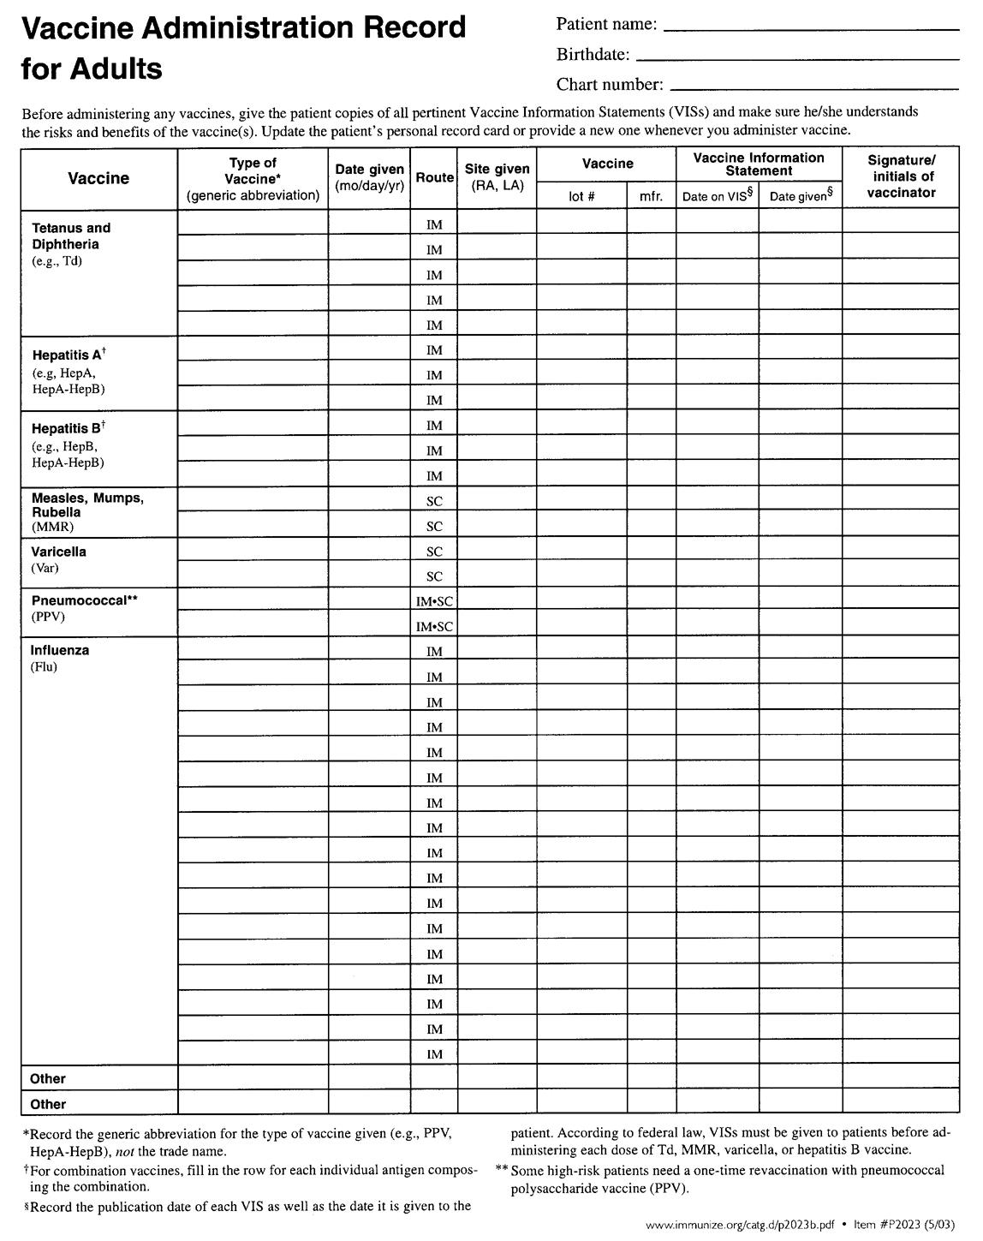

**Source:** [**www.immunize.org**](http://www.immunize.org)